**1.Background**

Our group has decided to focus on developing a comprehensive real estate management system that encompasses both corporate data organization and client service enhancement through a centralized database platform. This decision is rooted in the understanding that real estate agencies, especially those operating across multiple states like Dream Homes NYC, face significant challenges in maintaining consistent data management practices, delivering timely client services, and leveraging data for strategic insights.

Our research indicated that fragmented information systems can lead to inefficiencies, such as delayed transaction times, missed opportunities for property matching, and underutilized data for market analysis. By creating an integrated platform, we aim to address these issues head-on. This system will not only streamline the management of office locations, employee records, and financial data but also serve as a repository for all property listings, client interactions, and transaction histories. Additionally, it will facilitate better coordination among agents, enhance the client experience through more personalized and efficient service, and provide a foundation for data-driven decision-making.

The anticipated benefits of our project extend beyond operational efficiency and client satisfaction. By harnessing data analytics, Dream Homes NYC can gain insights into market trends, client preferences, and performance metrics across regions. This knowledge can inform strategic planning, marketing efforts, and service offerings, positioning the company for competitive advantage. Furthermore, the scalability of the database system ensures that it can evolve with the company's growth and adapt to future technologies, including potential app development, thereby supporting long-term innovation and success.

**2. Target Audience Analysis**

**Consultant/Client Scenario Description**

In this project, our client is a large real estate company looking to optimize its data management and decision-making processes. The company serves two primary user groups: data analysts and C-level executives. Data analysts require powerful tools for in-depth analysis and data mining, while C-level executives need intuitive dashboards to quickly grasp key business metrics and market trends.

**Reasons and Motivations for Choices**

The main motivation for offering customized services to these two user groups is to enhance the overall quality and efficiency of organizational decision-making. Analysts often need to perform complex data queries and analyses to uncover business insights, whereas senior management relies on these insights to strategize. By providing tools and data access tailored to their specific needs, we ensure that decision-makers at all levels can use data in the most effective way possible.

**Preliminary Research and Action Plan**

* **System Architecture Design**: Design the database and integrate existing data sources.
* **Dashboard Development**: Develop customized Tableau/Plotly dashboards for C-level executives.
* **Training and Deployment**: Train analysts and executives on system usage.
* **Feedback Loop**: Implement feedback mechanisms to optimize and adjust dashboards and reporting systems.

**How the Work Improves Company Decision-Making**

By providing accurate and real-time data views, executives can make data-driven decisions rapidly, such as market positioning and resource allocation. Analysts' access to deep analysis tools helps identify trends and patterns that might not be apparent to executives but are crucial for strategic planning. This synergy significantly enhances the timeliness and efficiency of decision-making. It also ensures that decision-makers at all levels have access to the same data and insights, fostering transparency and communication across departments. Additionally, it enables the company to respond swiftly to market changes, adjusting strategies to capitalize on new opportunities or to meet challenges.

**3. Database Interaction Plan**

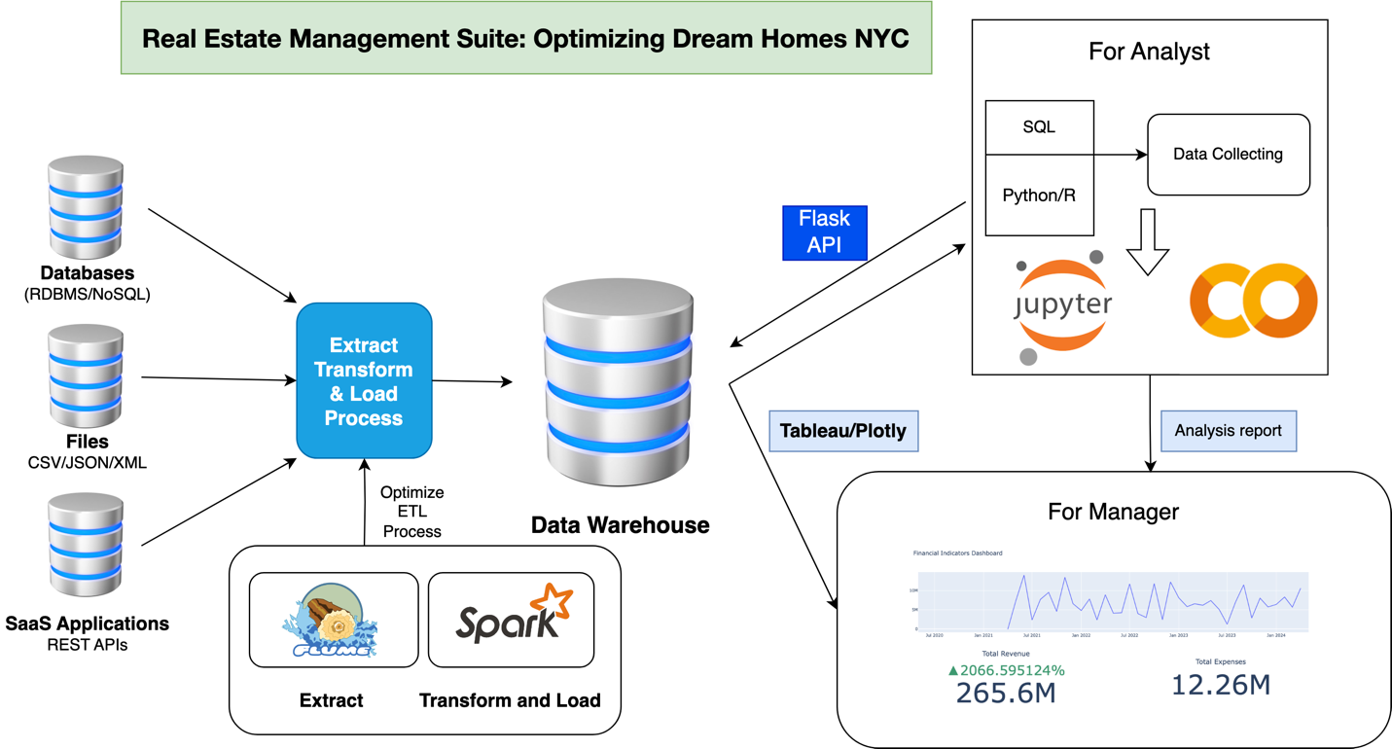

For the two types of users, I propose distinct usage scenarios tailored to their needs. Analysts are granted direct database access through a SQL interface, allowing them to use data analytics tools such as Power BI or Tableau for complex querying and deep data analysis. Furthermore, analysts benefit from data exploration and reporting tools provided through Jupyter Notebook, which offers a versatile environment for coding, performing analyses, and presenting results. On the other hand, C-level executives have access to custom dashboards built in Tableau that display key performance indicators (KPIs), market trends, and financial data. These dashboards are complemented by periodic reporting mechanisms that deliver automated reports regularly, such as monthly or quarterly, via email. These reports cover vital topics like sales performance, market analysis, and forecasts, ensuring executives stay informed of the latest business metrics.

This structured approach not only enhances the efficiency of data handling across different levels of the organization but also ensures that all stakeholders have access to the information necessary to make informed decisions. Through careful selection of technology and tools, such as MySQL for database management and Plotly for data visualization within Colab, we ensure robust data processing and interactive visual interfaces. Performance and redundancy are prioritized with regular automatic data backups to prevent data loss, load balancers to improve system response times and stability, and a failover mechanism through master-slave database replication to maintain service continuity during failures. The proposed dashboard for C-level executives, designed to provide a comprehensive overview of financial metrics, market dynamics, and operational metrics, aims to encapsulate critical business insights effectively. This visualization aids in tracking the trends of total revenue, expenses, net profit, new development projects, market share growth, home sales velocity, customer satisfaction, and employee performance in a clear and actionable manner.

**Tools and Programming Languages Used:**

* **Tools**: We utilize MySQL for database management, Jupyter Notebook for data analysis and reporting, Tableau for data visualization and dashboards, Plotly for interactive charts, and Colab for cloud-based code editing and execution.
* **Programming Language**: The primary programming language used is Python, which supports a wide range of data analysis libraries and the execution of SQL queries.

**Non-Technical User Interaction:**

Non-technical users interact with databases through customized Tableau dashboards, which do not require direct handling of database queries, ensuring that the interface is user-friendly and easy to understand.

**Redundancy and Performance Planning:**

We have implemented regular automatic data backups, load balancers to enhance system response times and stability, and a master-slave database replication failover mechanism to maintain service continuity.

**Database Hosting Location:**

The choice of hosting, either internally or in the cloud, is based on the enterprise's needs and resources. Cloud hosting offers scalability, flexibility, and cost-effectiveness, making it particularly suitable for environments requiring remote access or cross-geographic collaboration.

**4. Database**

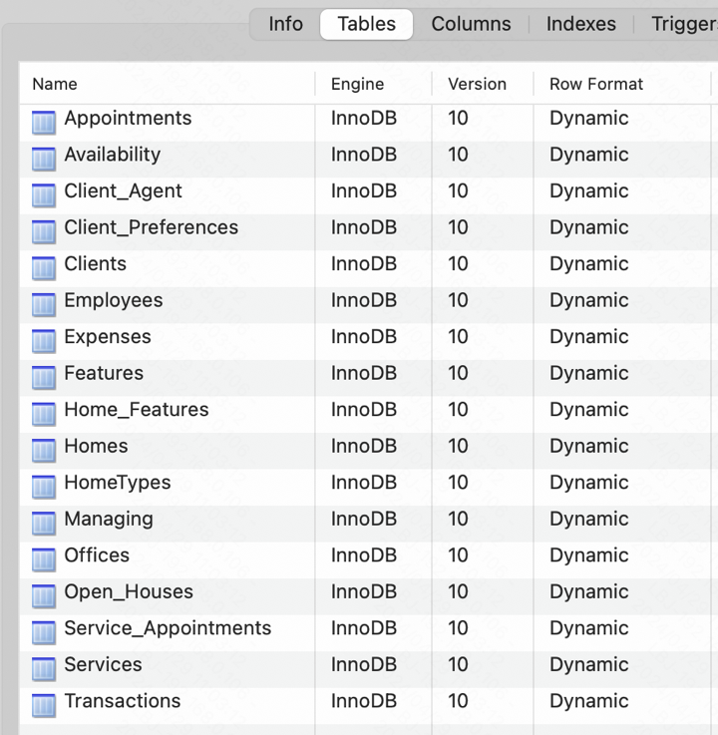

This project is based on data samples contained exclusively within five CSV files. We are utilizing MySQL as our database management system. The choice of MySQL over PostgreSQL is driven by two main factors:

* **Familiarity and Skill Level**: My proficiency with MySQL allows me to more effectively leverage this system for database design, maintenance, and optimization. This familiarity helps in avoiding the potential delays and errors that could arise from learning a new system, thereby enhancing the project's likelihood of success.
* **Structured Data Support**: MySQL offers exceptional support for structured data, which is the primary data type used in this project. Its strict schema enforcement and optimized query performance provide efficient read and write capabilities, making it well-suited for handling structured data efficiently.

**Dataset samples:**

clients dataset:

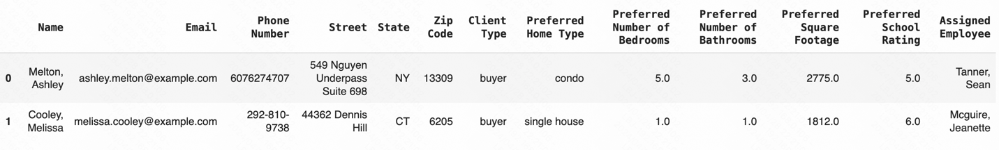

transactions dataset:

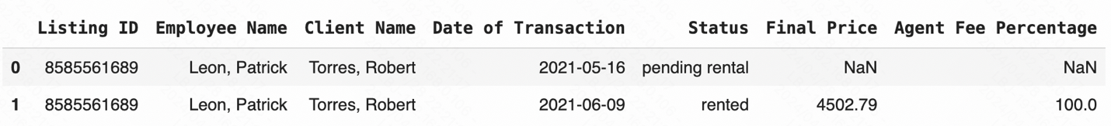

|  |  |  |  |
| --- | --- | --- | --- |
| **Table samples** | **Description** | **Relationship** | **Connection Key** |
| CLIENTS | Stores basic client information | Linked to EMPLOYEES and TRANSACTIONS tables | Assigned_Employee |
| EMPLOYEES | Contains detailed employee information | Linked to CLIENTS, TRANSACTIONS, and OFFICE_EXPENSES tables | Office_Name |
| TRANSACTIONS | Records details of each transaction | Linked to CLIENTS, EMPLOYEES, and HOME_LISTINGS tables | Listing_ID |
| HOME_LISTINGS | Contains information about all listings | Linked to TRANSACTIONS table | Listing_ID |
| OFFICE_EXPENSES | Records various expenses of the office | Linked to EMPLOYEES table | Office_Name |

**Reasons for selecting this dataset**

The datasets selected for the real estate management system are critical for integrating various aspects of the business, such as customer relationship management, transaction tracking, and expense management. By linking detailed employee data with client information, transaction details, and office expenses, the system enhances operational efficiency and strategic decision-making.

Each dataset is interconnected using specific keys, like 'Assigned_Employee' and 'Listing_ID', allowing for a comprehensive analysis of interactions between clients, employees, and property listings. This setup facilitates a seamless flow of information across different departments, improving both customer service and internal management practices.

**ER-diagrm**

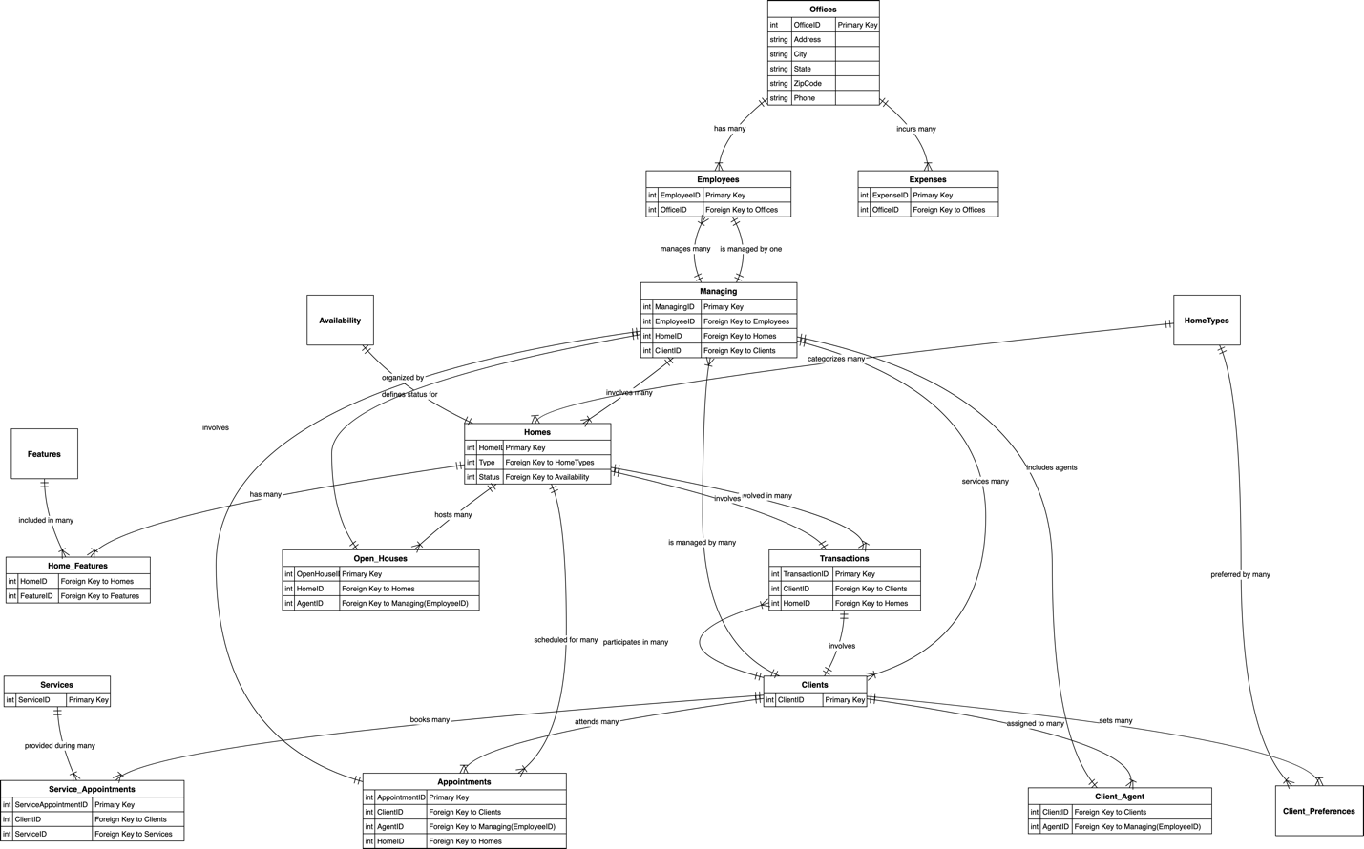

**Understanding Table Relationships**

* **Department Analogy:** Think of database tables like different departments in a company. For example, the "Employees" table holds all employee info, while the "Offices" table contains details about various office locations. These tables interact through specific links (e.g., which office an employee belongs to), similar to inter-departmental cooperation.
* **Simplified Explanation:** Each office has multiple employees, and each transaction involves a client and a property. These relationships are managed through foreign keys to ensure data consistency and integrity.

**Handling Automatic Storage and Effective Data Retrieval**

* **Automatic Storage:** Utilize database triggers for automated tasks like data backups and updates. Automation ensures data accuracy and reduces human errors.
* **Effective Retrieval:** Use indexing and partitioning akin to a library’s index cards or bookshelves to quickly and accurately locate data. Design queries efficiently, similar to going directly to the needed aisle in a supermarket.

**5. Normalization plan**

The normalization plan for the database is designed to optimize data management by ensuring the database is both practically robust and theoretically sound. Here’s a simplified explanation of the process:

* **First Normal Form (1NF)** ensures that each table field is atomic, without repeating columns, and that each data row can be uniquely identified by a primary key. This involves breaking down multi-valued attributes to ensure each field contains only a single data element.
* **Second Normal Form (2NF)** requires all non-primary key fields to be fully dependent on the primary key. This means eliminating partial dependencies by moving affected fields to a new table and linking them with a foreign key. For example, tables like Employees and Offices are already in 2NF.
* **Third Normal Form (3NF)** mandates that no non-primary key field depends on other non-primary key fields. Any such dependencies necessitate the creation of separate tables to house dependent fields.

While most databases require normalization up to 3NF, more complex forms like

Boyce-Codd Normal Form (BCNF) or Fourth Normal Form (4NF) might be needed for specific cases. The final steps involve reviewing and optimizing each table to ensure data types and sizes are suitable and that the design neither leads to inefficient querying due to over-normalization nor increases maintenance complexity due to redundancy. Testing involves evaluating the data models with various queries to check performance and integrity, followed by necessary adjustments to optimize the database structure. This structured approach ensures an efficient, well-maintained database that supports effective data handling and retrieval, crucial for smooth business operations.

**6. ETL Design**

ETL, which stands for Extract, Transform, and Load, is a key data processing method used to collect data from various sources, adjust it for analytical use, and store it in a database system. Initially, data is extracted from diverse sources like CSV files, involving the retrieval of raw data from its origin. The next step is transforming the data, which includes cleaning, standardizing data types, parsing dates, and adjusting file encodings to ensure the data is accurate and uniform. This phase also tackles combining data from different sources, handling missing values, removing duplicates and outliers, and manipulating features to prepare the data for analysis. Finally, this prepared data is loaded into a MySQL database, organized into 15 well-structured tables that adhere to the third normal form (3NF), enhancing both data integrity and access speed. This streamlined ETL process ensures the data is not only precise and comprehensive but also well-suited for effective querying and analysis within the system.

**7. Analysis Procedures**

**Question 1: What is the average preferred square footage by client type?**

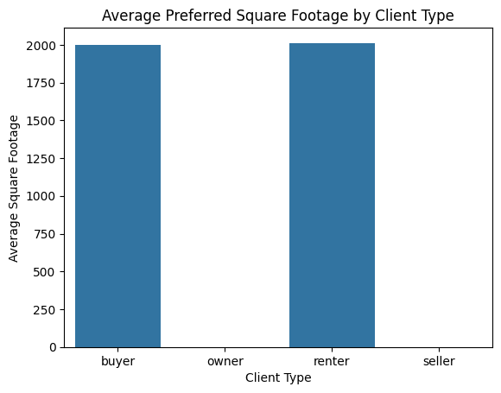

* Insight: Buyers and renters prefer larger properties, with average square footage just above 2000 sq ft. The absence of data for owners and sellers suggests a need for more comprehensive data collection.
* Recommendation: Focus marketing efforts on properties that align with these space preferences, especially targeting buyers and renters. Also, enhance data gathering for owners and sellers to better understand their preferences.

**Question 2: Most Popular Home Types Among Buyers and Renters**

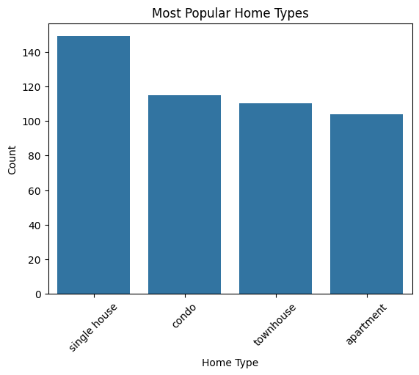

* Insight: Single houses are the most preferred type of home, followed by condos and townhouses.
* Recommendation: Prioritize inventory acquisition and marketing strategies for single houses, as they hold the greatest appeal. Consider diversifying listings to include a balanced mix of condos and townhouses to cater to varied preferences.

**Question 3: Employee with Highest Number of Sales Transactions**

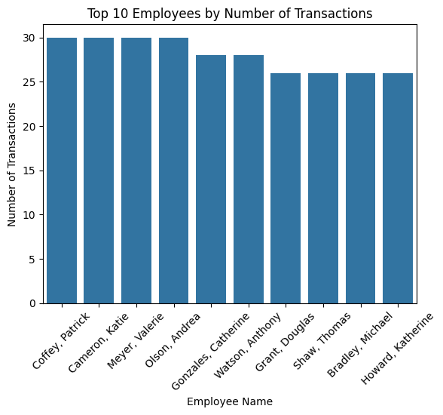

* Insight: Patrick Coffey leads with 30 transactions, indicating high productivity.
* Recommendation: Analyze Coffey's sales strategies and client interactions to derive best practices that can be implemented across the team to boost overall sales performance.

**Question 4: Trend of Sales Over Time**

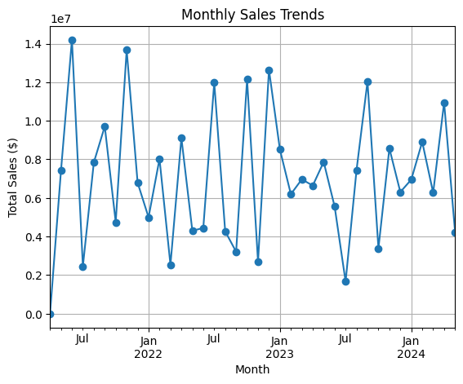

The provided data shows fluctuations in monthly sales from April 2021 through May 2024. There are notable peaks, such as in June 2021, November 2021, July 2022, October 2022, December 2022, and April 2024, suggesting significant sales activity in these months. Conversely, there are months like April 2021 and July 2023 with considerably lower sales, indicating a potential seasonal impact or external market influences.

**Question 5: Office with Highest Operational Expenses**

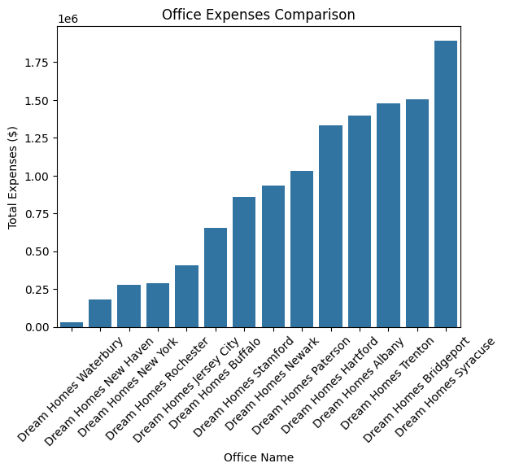

* Insight: Dream Homes Syracuse incurs the highest expenses.
* Recommendation: Conduct a thorough review of operational expenses at Syracuse to identify potential savings. Compare spending patterns across offices to standardize and optimize costs.

**Question 6: How does the client's preference for school ratings correlate with the house price they are looking for?**

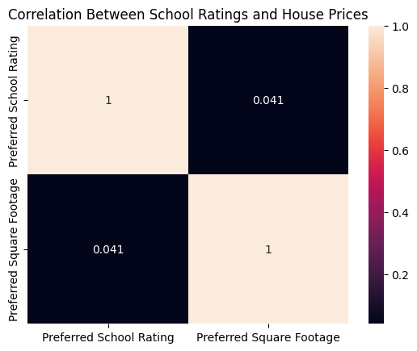

* Insight: There is a very weak correlation between school ratings and the preferred square footage, suggesting other factors might influence buying decisions more strongly.
* Recommendation: Focus on other selling points that might have a greater impact on client decision-making, such as location convenience, property amenities, and price.

**Question 7: What is the average time on the market for rented versus bought properties?**

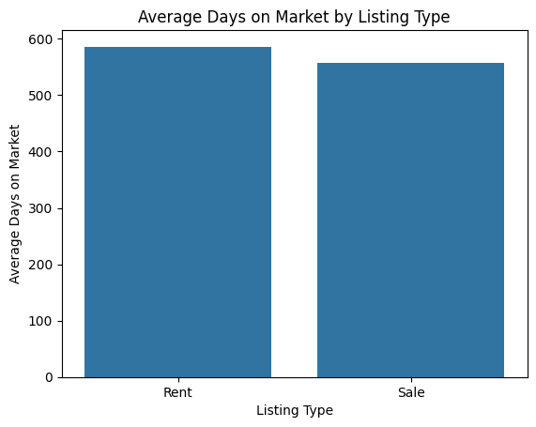

* Insight: Rental properties stay on the market slightly longer than properties for sale.
* Recommendation: Develop targeted strategies to reduce time on market for rentals, such as improved advertising, enhanced property features, or adjusted pricing strategies.

**Question 8: Which zip codes have the highest concentration of clients?**

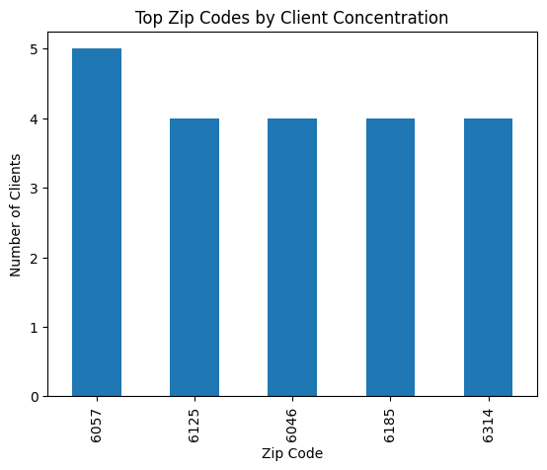

* Insight: Certain zip codes show higher concentrations of clients, indicating popular areas.
* Recommendation: Increase marketing and property development efforts in these zip codes to capitalize on the high demand. Consider exploring adjacent areas for expansion opportunities.

**Question 9. What are the sales patterns related to employee hire date?**

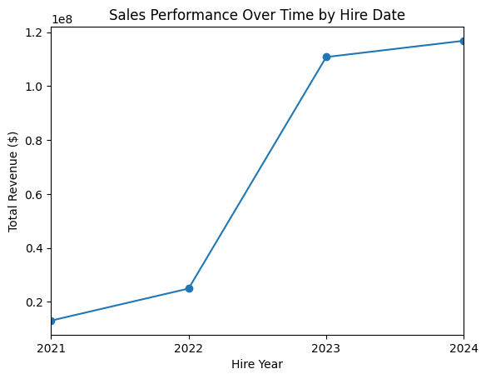

* Insight: The analysis of sales in relation to employee hire dates shows a substantial growth in total sales volume year over year from 2021 through 2024. This trend suggests that employees hired more recently could be becoming increasingly productive, or that the company's growth and experience accumulation over these years is positively impacting sales.
* Detailed Observations: Yearly Growth: Starting from approximately $13.05 million in sales in 2021, there is a significant upward trend, nearly doubling in 2022, and then seeing a sharp increase to over $110 million by 2023, which continues into 2024.

**Question 10: Which employees generate the most revenue, and how does this correlate with their base salary?**

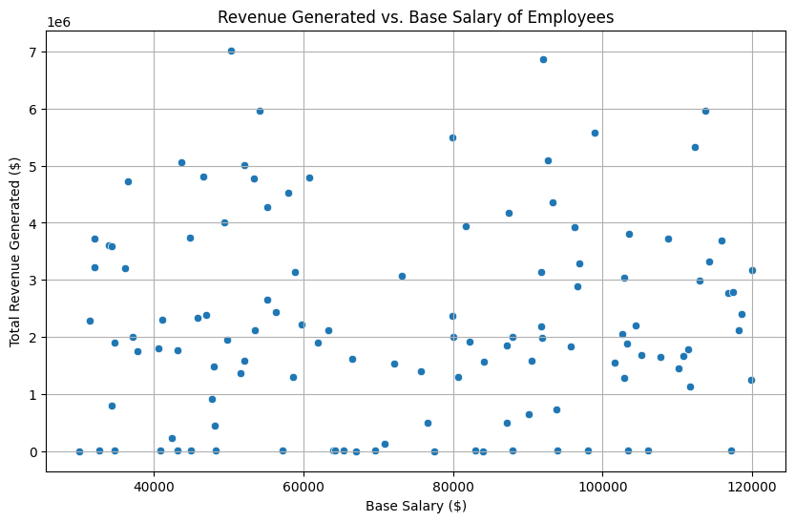

The graph shows that there is no relationship between an employee's base salary and the earnings he or she generates.

**Dashboard Analysis**

The dashboard demo presents an integrated view of key business metrics through three distinct yet interconnected panels: financial overview, market dynamics, and operational metrics.

**1. Financial Indicators Dashboard**

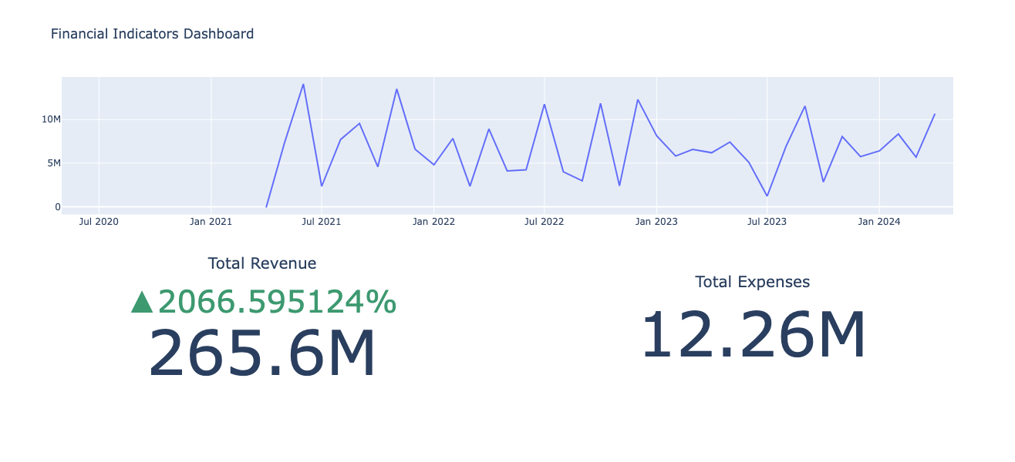

The financial overview dashboard is designed to provide a comprehensive understanding of the company's financial status, including trends in total revenue, total expenses, and net profit. This visualization allows management to stay informed about the company's financial performance, identify potential financial trends, and make strategic decisions. Managers use this dashboard to monitor the financial health of the business, track changes in income and expenditure to understand profitability and cost structures, and evaluate the net profit trend for insights into profit generation opportunities and strategic planning.

**2. Market Dynamics Dashboard**

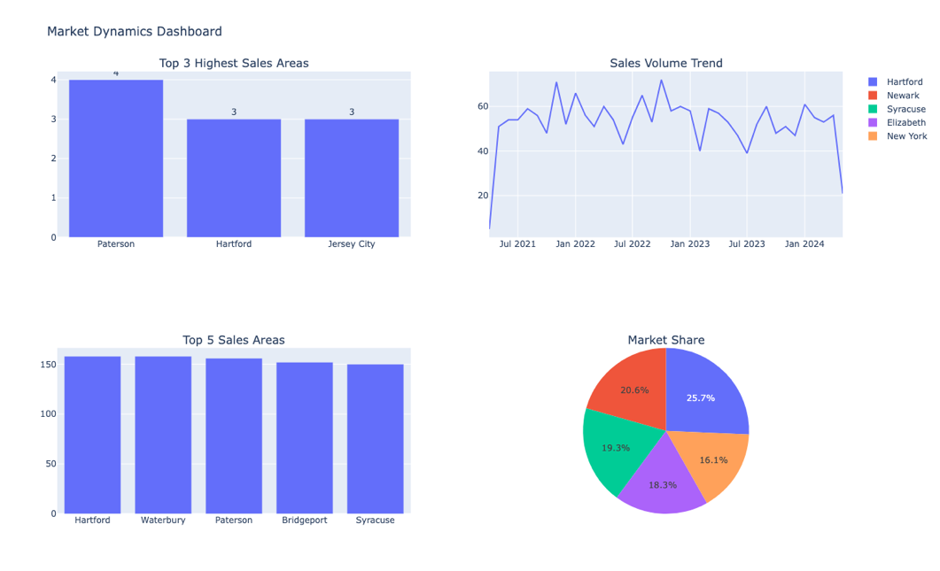

Meanwhile, the market dynamics dashboard aims to display the latest market developments and trends, including information on new projects, popular areas, and market share. With these visualizations, businesses can better understand market demand, identify market opportunities, and adjust marketing strategies accordingly. The marketing department utilizes this dashboard to track changes and trends in the market, spot new opportunities, and make adjustments based on market demands. Additionally, the sales team can leverage this tool to understand which regions are performing best and how market shares are distributed, thus optimizing their sales strategies.

**3. Operational Metrics Dashboard**

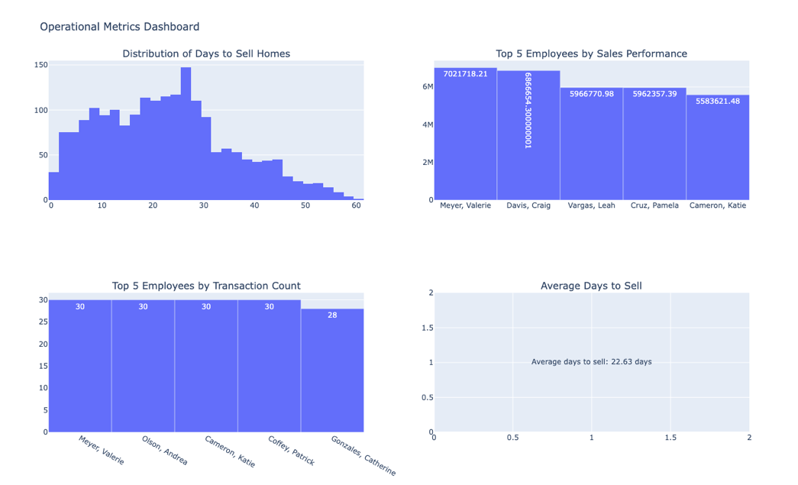

Lastly, the operational metrics dashboard focuses on showcasing the operational status and key performance indicators of the company, such as the speed of home sales and employee performance rankings. These visual data aids management in better understanding the operational aspects of the business, identifying potential issues, and taking appropriate actions. Sales teams can use this dashboard to gauge the pace of home sales and the performance of staff, recognizing top-performing employees and adjusting sales strategies accordingly. Moreover, management can monitor the company's operational performance, evaluate employee performance, and make informed management decisions based on these insights.

**Why I use Plotly rather than Tableau?**

In Tableau, there's a feature that allows connection to a database. Once the database is fully prepared, I can directly connect to it using Tableau and then use the various fields and keys from the tables. In my analysis, the reason Tableau can't create the best dashboard effect is due to the trend graph of net profit over time. This is because the net profit needs to be calculated by linking two tables and using the same time period as a common field to subtract total expenses from total revenue. So, this table is temporarily unable to be implemented in Tableau. Moving forward, I will further explore potential data analyses and use Tableau to implement them and connect with the database.

**Conclusion**

The goal of this project was to enhance the data management system of a large real estate company by optimizing its relational database management system (RDBMS), refining the ETL processes, and enhancing analytics capabilities.

**Achievements:**

* **RDBMS Optimization:** Implemented normalization principles to improve database efficiency, ensuring faster queries and enhanced data integrity.
* **Efficient ETL Processes:** Automated data extraction, transformation, and loading from CSV files into MySQL, ensuring data consistency and accuracy.
* **Advanced Analytics:** Deployed tools like Jupyter Notebook, Tableau, and Plotly to provide deep insights for data analysts and intuitive dashboards for executives.

**Client Benefits:**

* **Improved Decision-Making:** The enhancements allow for quicker, data-driven decisions that enhance strategic planning and operational efficiency.
* **Operational Efficiency:** Automation of data processes reduces manual errors and saves time, boosting productivity.
* **Insightful Data Access:** Tailored access to data empowers users with actionable insights, enhancing market understanding and competitive advantage.

In summary, by leveraging RDBMS, ETL, and analytics, the project significantly improved the company’s data management capabilities, supporting more strategic operations and future-ready adaptability.

**Link:**

Dashboard - <https://colab.research.google.com/drive/1CTB3J-nLAWimhvdv-3QXFl7_mQjwKxPs?usp=sharing>

ER-diagram - <https://viewer.diagrams.net/?page-id=BHPq0RaEakJ3ThHlrb-M&highlight=0000ff&edit=_blank&layers=1&nav=1&page-id=BHPq0RaEakJ3ThHlrb-M#G11hAI9fyt29mZyfHKXqNnE-nI8zQAP3yI>

**Appendix**

